20th March 2020

Dear Students,

Information for Pre – advanced Students

As I am sure you are all aware the Government have announced that schools and colleges will close from Monday 23rd March as part of the country’s ongoing response to coronavirus. In addition to this they also confirmed that exams scheduled for this summer will not go ahead.
The physical college may be closed to staff and students until further notice but studying and learning will very much continue. However if there is a critical reason for you to visit college it will be open from 9am-12:30pm everyday but there will only be a limited number of staff available. Your teachers will be setting you regular work for every lesson to complete by a variety of means including via e-mail, Microsoft teams, Moodle and other possible online platforms.

Your studies

- Check your college e-mail daily for work instructions from your teacher
- Complete the assigned activities
- Submit work as instructed by your teacher by the deadline
- The completion and engagement with this work will contribute towards your college forecast grades in April and June.
Your progression

- Your progression from the foundation year onto level 3 study will largely remain the same and be determined by two different pieces of information.

- Rather than your actual grades we will use your college forecast grades in June to determine eligibility onto level 3 study. These will be formed from the work you have done so far as well as the work you will do remotely.
- You will have to demonstrate a good attitude to learning and excellent attendance during your foundation year. You have been previously informed of this requirement during your foundation year. Whilst the college remains closed we will expect you to fully engage with the work being set by your teacher for you to progress to Level 3 study.

- Below is a summary of the entry criteria

Pathway | Grade to progress | Resits
Business and ICT | Distinction* | If resitting English GCSE you will need to have a college forecast of at least a grade 4.
Health and Social Care | Distinction*
Humanities | Two grade 4s
Media | Distinction*
*For automatic progression

Your teachers will be doing all they can to support your learning whilst the college is closed. It is important not only for your college forecast grades but also to maintain a high level of intellectual challenge ahead of the step up to Level 3 study.
If you have any queries regarding any matters detailed above please contact your personal tutor.

Yours sincerely

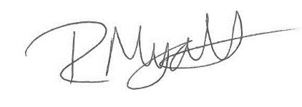

Rob Myatt
Deputy Principal

