Dewey Decimal Treasure Hunt

Computer Science, Knowledge, Systems (000)
004.67 TOW
First letter of the first word in the title

Philosophy and Psychology (100)
150 GRO
Second letter of the first word of the title

Religion (200)
241 VAR
First letter of the fourth word in the title

Social Sciences (300)
345.42 SMI
Third letter of the first word of the title

Languages (400)
427.09 AYT
Second letter of the last word

Science (500)
530.09 HAW
Fifth letter of the third word

Art and Recreation (700)
792 FEN
First letter of the third word of the title

Literature (800)
822.3 SHA ANT
Third letter of the title

History and Geography (900)
987.083 STE
First letter of the fifth word

Now combine the letters to form the title of a book which won the Orange Prize for Fiction
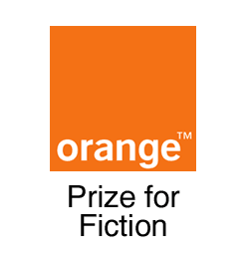

Please write down your name and hand in at the Hub Desk to be added to the prize draw!

